**A Study on Hand grinding process by ergonomic methods**

Suwin Kumar. L, Ramaganesh. K

**Abstract**

In the manufacturing process, grinding activities are crucial, particularly in the foundry division. Manual material handling is a requirement for employees in industrial settings. One of the tools used in manufacturing tasks, especially for metal processing, is a hand grinder. Typically, grinding is done during the product refining process to remove ridges from welded joints, for example. However, improper materials handling method can add to occupational injuries like back pain, Musculoskeletal disorders, etc. The purpose of this essay is to educate readers about the health risks associated with manual material handling and ergonomic risk factors. The primary causes of poor occupational health in manual materials handling tasks have been recognized as ergonomic risk factors, which include awkward posture, excessive load, and extreme temperature. The research on workers' discomfort in working settings is reviewed in this essay. The study's evaluation of occupationally-related causes of job discomfort is based on worker position, overall or partial body posture, and job activity. Postural activity recommendations are suggested summarizing the thresholds at which lower extremity discomfort has been observed based on the reviewed literature. The two simplest techniques for postural risk evaluation at work are RULA (Rapid Upper Limb evaluation) and REBA (Rapid Entire Body Assessment). The purpose of this research was to compare RULA and REBA and assess the operator's postures during the angular grinding process in order to determine which postures were more suitable and effective for risk assessment.

Keywords: ergonomics, injuries, handling, worker

**1. Introduction:**

There are many different kinds of dangers, health risks, and accidents. The foundry site's character is distinctive, hazardous, and dynamic. There are many different work postures used in the office. Numerous uncomfortable static positions can put workers at risk for severe MSDs. More employees now suffer from back injuries, sprains, and muscle stress as a result. The issue will also be deadly if the exposure is sustained for a long time. Since there are more actions taking place in one location, it requires numerous operations. So, there are various working postures for each task in the. The work postures that were collected for this research came from the angular grinding process. Workers thus encounter numerous physical challenges. foundry site is unique, dangerous and dynamic. There are many different work postures used in the office. Numerous uncomfortable static positions can put workers at risk for severe MSDs. More employees now suffer from back injuries, sprains, and muscle stress as a result. The issue will also be deadly if the exposure is sustained for a long time. Since there are more actions taking place in one location, it requires numerous operations. So, there are various working postures for each task in it. The work postures that were collected for this research came from the angular grinding process. Workers thus encounter numerous physical challenges.The prevalence of work-related musculoskeletal disorders (WMSDs) is a significant issue for the industry, which can also be negatively impacted by expenses for worker compensation, labour turnover, absenteeism, poor quality, and decreased output. They result in worksite dangers, poor worker health, mechanical equipment injuries, disabilities, and work-related musculoskeletal disorders (WMSDs), which in turn lower worker productivity, lower-quality products, and higher costs. Therefore, achieving the goals of the manufacturing sectors would be incredibly challenging without giving ergonomics the proper consideration. A balance between worker characteristics and job demands can be achieved through the effective application of ergonomics in work system design. Numerous studies have demonstrated the benefits of implementing ergonomics principles in the creation of workplaces, machines, jobs, environments, and facilities Ergonomics has a very broad range of applications and does not only apply to certain industries. People are involved in ergonomics, if properly designed, work systems, leisure activities, sports, and health and safety should all incorporate ergonomics concepts. People's physical and mental capabilities, the physical and mental demands of their jobs, and the physical and organizational setting in which they are working all have an impact on their ability to perform their jobs. The ability of people to use correctly designed equipment, frequently in challenging working conditions, is a sign of their adaptability. They can put up with minor deviations from the ideal designs of the tools they use and the settings in which they operate. All employees, including those from vendors, are, however, educated in ergonomics and EHS, along with other important topics.

**2. Methodology**

**2.1. Problem identification:**

Through risk assessment, ergonomic hazards must be found early on, and the job position and movements must be changed. This risk may result in back injuries, musculoskeletal disorders linked to the job, and labour-related sprains and strains. Injury-related to ergonomics includes those brought on by ergonomic risk factors, such as:

Many awkward work postures are present in the work processes that were collected for this research. Manufacturing and the Foundry divisions are the sectors covered in this work. Workers' unpleasant static positions, forceful repetitive movements, vibration, contact stress on muscles and tendons, bending, twisting, kneeling, using the arms above shoulder level, and extreme temperatures are the main causes of MSDs. Additionally, vibration and power from gripping, lifting, pushing, or tugging may be present. Lacerations, injuries to the lumbar vertebrae, upper extremities, and eye injuries are the most common injuries brought on by these risk factors. Because they are worried of losing their jobs, employees tend not to talk about the suffering that occurs to them when they perform the same tasks over and over again. Production often takes precedence over employee protection in workplaces. Numerous risks have an impact on worker health both directly and tangentially. Another significant issue in the process of angular grinding is work position. Awkward postures at work can have both short- and long-term impacts on the workers.

The ergonomic hazard includes,

* Overexertion
* Poor posture.
* Repetitive awkward movements.
* Static posture
* Awkward postures
* Bending and Twisting movements

**2.2. RULA & REBA:**

Rapid upper limb assessment (RULA) and Rapid entire body assessment (REBA) are primarily used to determine the risk present in the worker's upper limb and complete body. The upper limb consists of the neck, torso, legs, upper arm, lower arm, wrist, wrist twist, and muscles use and load. If the score is low in the RULA & REBA assessment, the posture condition is improved. There are 10 poses chosen for the REBA & RULA assessment.

|  |  |
| --- | --- |
| **Ergonomics Matrix** | |
| **SCORE** | **Level Of risk** |
| **1 OR 2** | **Negligible risk, Acceptable.** |
| **3 OR 4** | **Low risk, Change may be needed.** |
| **5 OR 6** | **medium risk, Investigate and change soon.** |
| **7+** | **Very high risk, Investigate and change immediately.** |

**2.2.1 Posture-1:**

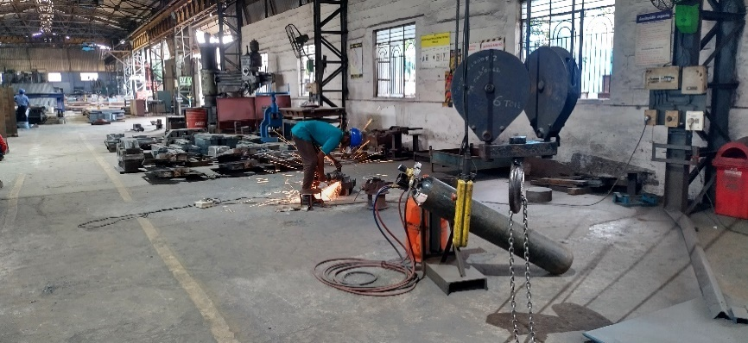

**Figure 2.1 Posture-1**

**TABLE 1: Data are Observed and gathered from the worker doing the task.**

|  |  |  |  |
| --- | --- | --- | --- |
| **Hand grinding questionnaire Survey** | | **Operator** | |
| **S.no** | **Questions** | **Yes** | **No** |
| **1** | **Operators are trained of using angular grinder** | * |  |
| **2** | **Are there any flammable materials near** | * |  |
| **3** | **Fire extinguisher is nearby** | * |  |
| **4** | **Whether tool box talk conducted regarding Work safety** | * |  |
| **5** | **Whether machine visual inspection is done before start of work** | * |  |
| **6** | **Appropriate PPE is used** |  | * |
| **7** | **Guarding and handles is placed** | * |  |
| **8** | **Whether electric wire cable is insulated properly** | * |  |
| **9** | **Correct cutting wheel or disc is used for appropriate activity** | * |  |
| **S.no** | **Questions** | **Hand Grinding** | **Feedback** |
| **1** | How many hours it takes to do the process (<1 hrs)/ (3 to 5 hrs)/ (> 5 Hrs) | 6hrs (8 hrs shift time) | Max 9 mins for single Casing |

**TABLE 2: The risk level is determined using the statistics mentioned above.**

|  |  |  |
| --- | --- | --- |
| **S.no** | **Ergonomic Hazards** | **Risk Level** |
| 1 | Fatigue level | Medium |
| 2 | Noise Level | High |
| 3 | Awkward posture | High |
| 4 | Process Repetition | High |
| 5 | Vibration level | High |
| 6 | Force Applied | Low |
| 7 | Workplace Temperature | Medium |
| 8 | Static Posture | High |
| 9 | Repetitive motion | High |
| 10 | Interval given during the process | Medium |
| 11 | Workplace Lighting | Medium |



When the risk is assessed, the worker displays awkward posture while performing the task. Because the risk scores in RULA and REBA are 6 (Medium) and 8 (High), respectively, an investigation must be conducted right away, and the required steps must be taken to design the work ergonomically.

**2.2.2 Posture-2:**

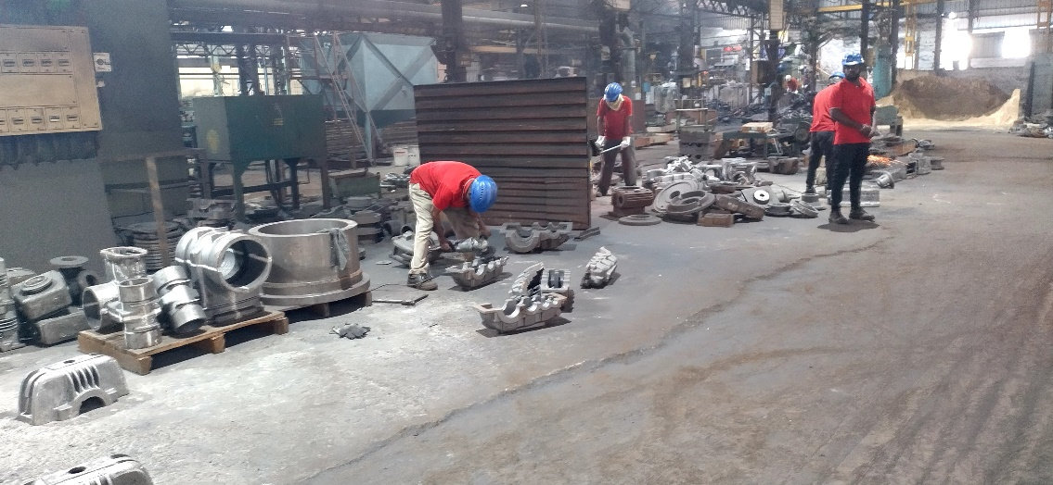

**Fig 2.4 Posture-2**

**TABLE 3: Data are gathered from the worker doing the task.**

|  |  |  |  |
| --- | --- | --- | --- |
| **Hand grinding questionnaire Survey** | | **Operator** | |
| **S.no** | **Questions** | **Yes** | **No** |
| **1** | **Operators are trained of using angular grinder** | * |  |
| **2** | **Are there any flammable materials near** | * |  |
| **3** | **Fire extinguisher is nearby** | * |  |
| **4** | **Whether tool box talk conducted regarding Work safety** | * |  |
| **5** | **Whether machine visual inspection is done before start of work** | * |  |
| **6** | **Appropriate PPE is used** |  | * |
| **7** | **Guarding and handles is placed** | * |  |
| **8** | **Whether electric wire cable is insulated properly** | * |  |
| **9** | **Correct cutting wheel or disc is used for appropriate activity** | * |  |
| **S.no** | **Questions** | **Hand Grinding** | **Feedback** |
| 1 | How many hours it takes to do the process (<1 hrs)/ (3 to 5 hrs)/ (> 5 Hrs) | 6hrs 50 mins (8 hrs shift time) | Max 11 mins for single Casing |

**TABLE 4: The risk level is determined using the statistics mentioned above.**

|  |  |  |
| --- | --- | --- |
| **S.no** | **Ergonomic Hazards** | **Risk Level** |
| 1 | Fatigue level | Medium |
| 2 | Noise Level | High |
| 3 | Awkward posture | High |
| 4 | Process Repetition | High |
| 5 | Vibration level | High |
| 6 | Force Applied | Low |
| 7 | Workplace Temperature | Medium |
| 8 | Static Posture | High |
| 9 | Repetitive motion | High |
| 10 | Interval given during the process | Medium |
| 11 | Workplace Lighting | Medium |
|  |  |  |



**Fig 2.5 RULA ASSESSMENT WORKSHEET**

**Fig 2.6 REBA ASSESSMENT WORKSHEET**

When the danger is being assessed, the worker displays awkward posture. Since the risk score in RULA is 6 (Medium) and REBA is 10 (High), an investigation must be conducted right away, and the required steps must be taken to create the work in an ergonomically sound manner.

**2.2.3 Posture-3:**

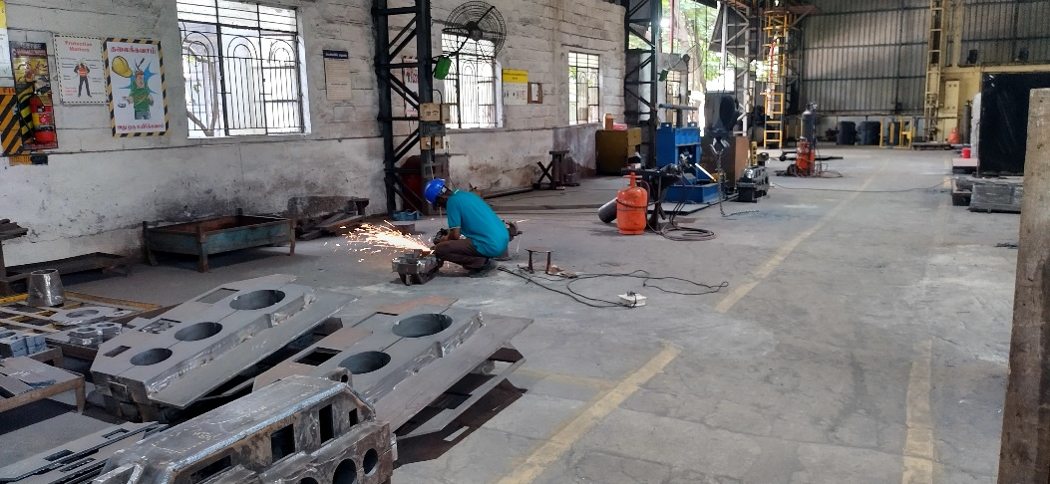

**Fig 2.7 Posture-3**

|  |  |  |  |
| --- | --- | --- | --- |
| **Hand grinding questionnaire Survey** | | **Operator** | |
| **S.no** | **Questions** | **Yes** | **No** |
| **1** | **Operators are trained of using angular grinder** | * |  |
| **2** | **Are there any flammable materials near** | * |  |
| **3** | **Fire extinguisher is nearby** | * |  |
| **4** | **Whether tool box talk conducted regarding Work safety** | * |  |
| **5** | **Whether machine visual inspection is done before start of work** | * |  |
| **6** | **Appropriate PPE is used** |  | * |
| **7** | **Guarding and handles is placed** | * |  |
| **8** | **Whether electric wire cable is insulated properly** | * |  |
| **9** | **Correct cutting wheel or disc is used for appropriate activity** | * |  |

**TABLE 5: Data are gathered from the worker doing the task.**

|  |  |  |  |
| --- | --- | --- | --- |
| **S.no** | **Questions** | **Hand Grinding** | **Feedback** |
| 1 | How many hours it takes to do the process (<1 hrs)/ (3 to 5 hrs)/ (> 5 Hrs) | 6hrs 40 mins (8 hrs shift time) | Max 9 mins for single Casing |

**TABLE 6: The risk level is determined using the statistics mentioned above.**

|  |  |  |
| --- | --- | --- |
| **S.no** | **Ergonomic Hazards** | **Risk Level** |
| 1 | Fatigue level | Medium |
| 2 | Noise Level | High |
| 3 | Awkward posture | High |
| 4 | Process Repetition | High |
| 5 | Vibration level | High |
| 6 | Force Applied | Low |
| 7 | Workplace Temperature | Medium |
| 8 | Static Posture | High |
| 9 | Repetitive motion | High |
| 10 | Interval given during the process | Medium |
| 11 | Workplace Lighting | Medium |



In RULA, the risk number is 6 (Medium), while in REBA, it is 8. (High). which indicates that in order to prevent any injuries, quick action must be done.

**2.2.4 Posture 4:**

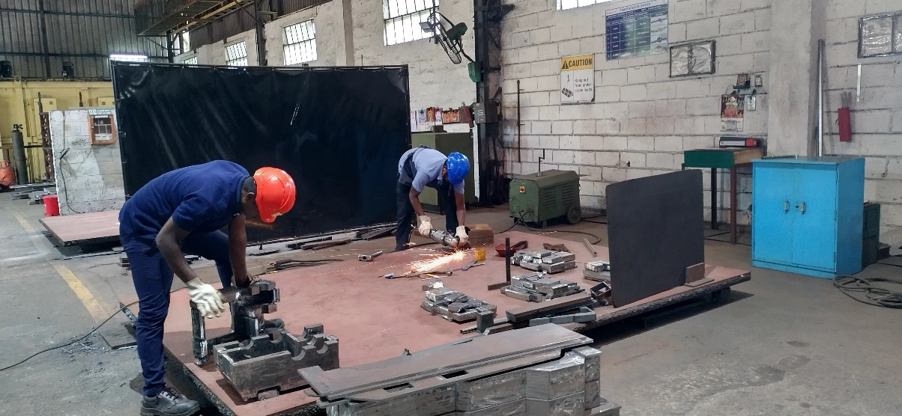

**Fig 2.10 Posture-4**

**TABLE 7: Data are gathered from the worker doing the task.**

|  |  |  |  |
| --- | --- | --- | --- |
| **Hand grinding questionnaire Survey** | | **Operator** | |
| **S.no** | **Questions** | **Yes** | **No** |
| **1** | **Operators are trained of using angular grinder** | * |  |
| **2** | **Are there any flammable materials near** | * |  |
| **3** | **Fire extinguisher is nearby** | * |  |
| **4** | **Whether tool box talk conducted regarding Work safety** | * |  |
| **5** | **Whether machine visual inspection is done before start of work** | * |  |
| **6** | **Appropriate PPE is used** |  | * |
| **7** | **Guarding and handles is placed** | * |  |
| **8** | **Whether electric wire cable is insulated properly** | * |  |
| **9** | **Correct cutting wheel or disc is used for appropriate activity** | * |  |
| **S.no** | **Questions** | **Hand Grinding** | **Feedback** |
| 1 | How many hours it takes to do the process (<1 hrs)/ (3 to 5 hrs)/ (> 5 Hrs) | 6 hours (8 hrs shift time) | Max 9 mins for single Casing |

**TABLE 8: The risk level is determined using the statistics mentioned above.**

|  |  |  |
| --- | --- | --- |
| **S.no** | **Ergonomic Hazards** | **Risk Level** |
| 1 | Fatigue level | Medium |
| 2 | Noise Level | High |
| 3 | Awkward posture | High |
| 4 | Process repetition | High |
| 5 | Vibration level | High |
| 6 | Force Applied | Low |
| 7 | Workplace Temperature | Medium |
| 8 | Static Posture | High |
| 9 | Repetitive motion | High |
| 10 | Interval given during the process | Medium |
| 11 | Workplace Lighting | Medium |



**Fig 2.11 RULA ASSESSMENT WORKSHEET**

**Fig 2.12 REBA ASSESSMENT WORKSHEET**

In this evaluation, RULA's risk score is 6 (Medium), while REBA's risk score is 10. (High). which indicates that quick action is required to prevent any accidents.

**2.2.5 Posture-5:**

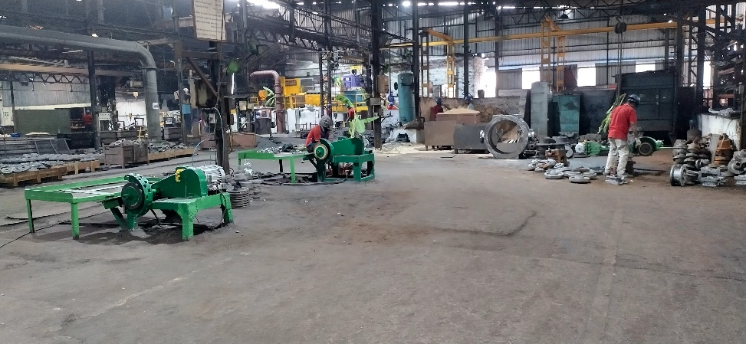

**Fig 2.13 Posture-5**

|  |  |  |  |
| --- | --- | --- | --- |
| **Hand grinding questionnaire Survey** | | **Operator** | |
| **S.no** | **Questions** | **Yes** | **No** |
| **1** | **Operators are trained of using angular grinder** | * |  |
| **2** | **Are there any flammable materials near** | * |  |
| **3** | **Fire extinguisher is nearby** | * |  |
| **4** | **Whether tool box talk conducted regarding Work safety** | * |  |
| **5** | **Whether machine visual inspection is done before start of work** | * |  |
| **6** | **Appropriate PPE is used** |  | * |
| **7** | **Guarding and handles is placed** | * |  |
| **8** | **Whether electric wire cable is insulated properly** | * |  |
| **9** | **Correct cutting wheel or disc is used for appropriate activity** | * |  |

**TABLE 9: DATA Observed and collected from the worker doing the task**

|  |  |  |  |
| --- | --- | --- | --- |
| **S.no** | **Questions** | **Hand Grinding** | **Feedback** |
| 1 | How many hours it takes to do the process (<1 hrs)/ (3 to 5 hrs)/ (> 5 Hrs) | 3 hours (8 hrs shift time) | Max 6 mins for tiny pieces |

**TABLE 10: The risk level is determined using the statistics mentioned above.**

|  |  |  |
| --- | --- | --- |
| **S.no** | **Ergonomic Hazards** | **Risk Level** |
| 1 | Fatigue level | Low |
| 2 | Noise Level | High |
| 3 | Awkward posture | Low |
| 4 | Process repetition | Medium |
| 5 | Vibration level | Medium |
| 6 | Force Applied | Medium |
| 7 | Workplace Temperature | Medium |
| 8 | Static Posture | Medium |
| 9 | Repetitive motion | Medium |
| 10 | Interval given during the process | High |
| 11 | Workplace Lighting | Medium |

********

The risk is assessed. Investigation is required because the risk score for RULA is 4 (Low) and the risk score for REBA is 6 (Medium).

**2.2.6 Posture-6:**

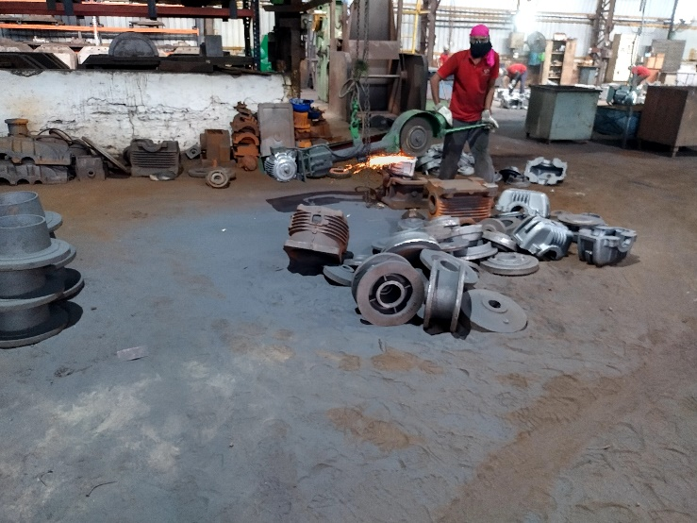

**Fig 2.15 Posture-6**

**TABLE 11: DATA Observed and collected from the worker doing the task**

|  |  |  |  |
| --- | --- | --- | --- |
| **Hand grinding questionnaire Survey** | | **Operator** | |
| **S.no** | **Questions** | **Yes** | **No** |
| **1** | **Operators are trained of using angular grinder** | * |  |
| **2** | **Are there any flammable materials near** | * |  |
| **3** | **Fire extinguisher is nearby** | * |  |
| **4** | **Whether tool box talk conducted regarding Work safety** | * |  |
| **5** | **Whether machine visual inspection is done before start of work** | * |  |
| **6** | **Appropriate PPE is used** |  | * |
| **7** | **Guarding and handles is placed** | * |  |
| **8** | **Whether electric wire cable is insulated properly** | * |  |
| **9** | **Correct cutting wheel or disc is used for appropriate activity** | * |  |
| **S.no** | **Questions** | **Hand Grinding** | **Feedback** |
| 1 | How many hours it takes to do the process (<1 hrs)/ (3 to 5 hrs)/ (> 5 Hrs) | 6 hrs 45 mins (8 hrs shift time) | Max 10 mins for single Casing |

|  |  |  |
| --- | --- | --- |
| **S.no** | **Ergonomic Hazards** | **Risk Level** |
| 1 | Fatigue level | Low |
| 2 | Noise Level | High |
| 3 | Awkward posture | Low |
| 4 | Process repetition | Medium |
| 5 | Vibration level | Medium |
| 6 | Force Applied | Medium |
| 7 | Workplace Temperature | Medium |
| 8 | Static Posture | Medium |
| 9 | Repetitive motion | Medium |
| 10 | Interval given during the process | High |
| 11 | Workplace Lighting | Medium |

**TABLE 12: The risk level is determined using the statistics mentioned above.**





The danger is assessed. Investigation is necessary because REBA has a risk score of 6 (Medium) and RULA has a risk score of 4.

**2.2.7 Posture-7:**

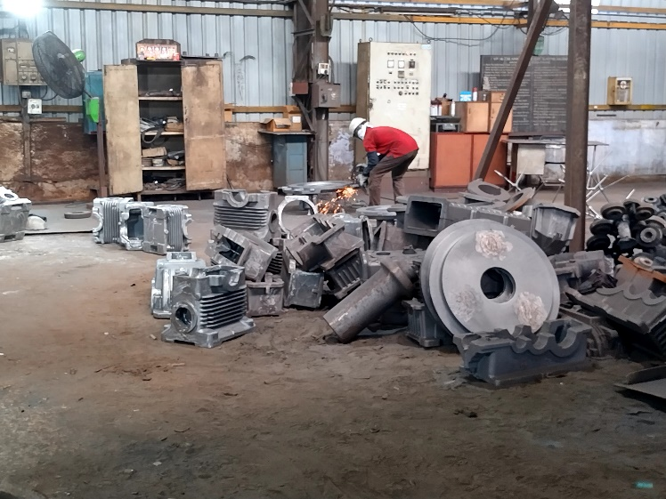

**Fig 2.18 Posture-7**

**TABLE 13: DATA Observed and collected from the worker doing the task**

|  |  |  |  |
| --- | --- | --- | --- |
| **S.no** | **Questions** | **Yes** | **No** |
| **1** | **Operators are trained of using angular grinder** | * |  |
| **2** | **Are there any flammable materials near** | * |  |
| **3** | **Fire extinguisher is nearby** | * |  |
| **4** | **Whether tool box talk conducted regarding Work safety** | * |  |
| **5** | **Whether machine visual inspection is done before start of work** | * |  |
| **6** | **Appropriate PPE is used** |  | * |
| **7** | **Guarding and handles is placed** | * |  |
| **8** | **Whether electric wire cable is insulated properly** | * |  |
| **9** | **Correct cutting wheel or disc is used for appropriate activity** | * |  |
| **S.no** | **Questions** | **Hand Grinding** | **Feedback** |
| 1 | How many hours it takes to do the process (<1 hrs)/ (3 to 5 hrs)/ (> 5 Hrs) | 6 hours (8 hrs shift time) | Max 7 mins for single Casing |

**TABLE 14: The risk level is determined using the statistics mentioned above.**

|  |  |  |
| --- | --- | --- |
| **S.no** | **Ergonomic Hazards** | **Risk Level** |
| 1 | Fatigue level | Medium |
| 2 | Noise Level | High |
| 3 | Awkward posture | High |
| 4 | Process repetition | Medium |
| 5 | Vibration level | High |
| 6 | Force Applied | Low |
| 7 | Workplace Temperature | Medium |
| 8 | Static Posture | High |
| 9 | Repetitive motion | High |
| 10 | Interval given during the process | Medium |
| 11 | Workplace Lighting | Medium |

********

In this evaluation, RULA's risk score is 6 (Medium), while REBA's risk score is 11. (Very High). which indicates that in order to prevent any injuries, quick action must be done.

**2.2.8 Posture-8:**

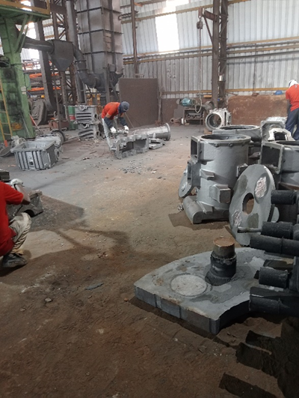

**Fig 2.21 Posture-8**

**TABLE 15: DATA Observed and collected from the worker doing the task**

|  |  |  |  |
| --- | --- | --- | --- |
| **Hand grinding questionnaire Survey** | | **Operator** | |
| **S.no** | **Questions** | **Yes** | **No** |
| **1** | **Operators are trained of using angular grinder** | * |  |
| **2** | **Are there any flammable materials near** | * |  |
| **3** | **Fire extinguisher is nearby** | * |  |
| **4** | **Whether tool box talk conducted regarding Work safety** | * |  |
| **5** | **Whether machine visual inspection is done before start of work** | * |  |
| **6** | **Appropriate PPE is used** |  | * |
| **7** | **Guarding and handles is placed** | * |  |
| **8** | **Whether electric wire cable is insulated properly** | * |  |
| **9** | **Correct cutting wheel or disc is used for appropriate activity** | * |  |
| **S.no** | **Questions** | **Hand Grinding** | **Feedback** |
| 1 | How many hours it takes to do the process (<1 hrs)/ (3 to 5 hrs)/ (> 5 Hrs) | 6hrs10 mins  (8 hrs shift time) | Max 7 mins for single Casing |

**TABLE 16: The risk level is determined using the statistics mentioned above.**

|  |  |  |
| --- | --- | --- |
| **S.no** | **Ergonomic Hazards** | **Risk Level** |
| 1 | Fatigue level | Medium |
| 2 | Noise Level | High |
| 3 | Awkward posture | High |
| 4 | Process repetition | High |
| 5 | Vibration level | High |
| 6 | Force Applied | Low |
| 7 | Workplace Temperature | Medium |
| 8 | Static Posture | High |
| 9 | Repetitive motion | High |
| 10 | Interval given during the process | Medium |
| 11 | Workplace Lighting | Medium |





When the risk is assessed, the worker displays awkward posture while performing the task. Because the risk scores in RULA and REBA are 6 (Medium) and 8 (High), respectively, an investigation must be conducted right away, and the required steps must be taken to design the work ergonomically.

**2.2.9 Posture-9:**

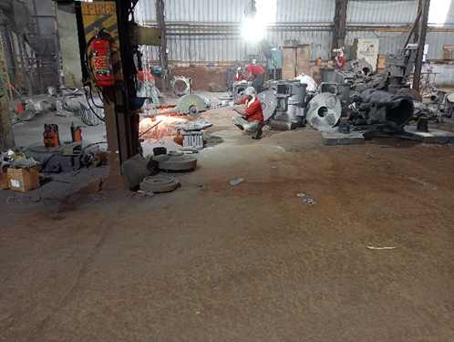

**Fig 2.24 Posture-9**

**TABLE 17: DATA Observed and collected from the worker doing the task**

|  |  |  |  |
| --- | --- | --- | --- |
| **Hand grinding questionnaire Survey** | | **Operator** | |
| **S.no** | **Questions** | **Yes** | **No** |
| **1** | **Operators are trained of using angular grinder** | * |  |
| **2** | **Are there any flammable materials near** | * |  |
| **3** | **Fire extinguisher is nearby** | * |  |
| **4** | **Whether tool box talk conducted regarding Work safety** | * |  |
| **5** | **Whether machine visual inspection is done before start of work** | * |  |
| **6** | **Appropriate PPE is used** |  | * |
| **7** | **Guarding and handles is placed** | * |  |
| **8** | **Whether electric wire cable is insulated properly** | * |  |
| **9** | **Correct cutting wheel or disc is used for appropriate activity** | * |  |
| **S.no** | **Questions** | **Hand Grinding** | **Feedback** |
| 1 | How many hours it takes to do the process (<1 hrs)/ (3 to 5 hrs)/ (> 5 Hrs) | 5hrs20 mins  (8 hrs shift time) | Max 7 mins for single Casing |

**TABLE 18: The risk level is determined using the statistics mentioned above.**

|  |  |  |
| --- | --- | --- |
| **S.no** | **Ergonomic Hazards** | **Risk Level** |
| 1 | Fatigue level | Medium |
| 2 | Noise Level | High |
| 3 | Awkward posture | High |
| 4 | Process repetition | Medium |
| 5 | Vibration level | High |
| 6 | Force Applied | Low |
| 7 | Workplace Temperature | Medium |
| 8 | Static Posture | High |
| 9 | Repetitive motion | High |
| 10 | Interval given during the process | Medium |
| 11 | Workplace Lighting | Medium |

********

When the danger is assessed, the worker displays awkward posture while performing the task. The risk score in RULA is 6 (Medium), and the risk score in REBA is 10, indicating that an inquiry must be conducted right away and that the work must be designed ergonomically.

**2.2.10 Posture-10:**

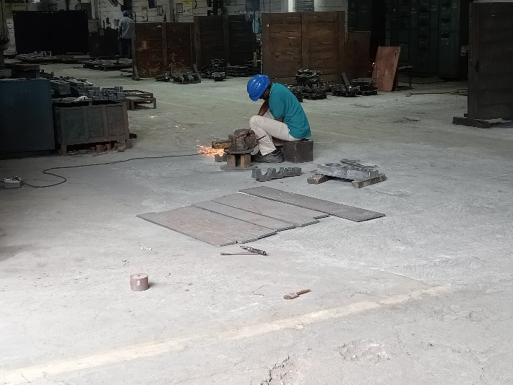

**Fig 2.27 Posture-10**

**TABLE 19: DATA Observed and collected from the worker doing the task**

|  |  |  |  |
| --- | --- | --- | --- |
| **Hand grinding questionnaire Survey** | | **Operator** | |
| **S.no** | **Questions** | **Yes** | **No** |
| **1** | **Operators are trained of using angular grinder** | * |  |
| **2** | **Are there any flammable materials near** | * |  |
| **3** | **Fire extinguisher is nearby** | * |  |
| **4** | **Whether tool box talk conducted regarding Work safety** | * |  |
| **5** | **Whether machine visual inspection is done before start of work** | * |  |
| **6** | **Appropriate PPE is used** |  | * |
| **7** | **Guarding and handles is placed** | * |  |
| **8** | **Whether electric wire cable is insulated properly** | * |  |
| **9** | **Correct cutting wheel or disc is used for appropriate activity** | * |  |
| **S.no** | **Questions** | **Hand Grinding** | **Feedback** |
| 1 | How many hours it takes to do the process (<1 hrs)/ (3 to 5 hrs)/ (> 5 Hrs) | 6 hrs  (8 hrs shift time) | Max 10 mins for single Casing |

|  |  |  |
| --- | --- | --- |
| **S.no** | **Ergonomic Hazards** | **Risk Level** |
| 1 | Fatigue level | Medium |
| 2 | Noise Level | High |
| 3 | Awkward posture | High |
| 4 | Process repetition | High |
| 5 | Vibration level | High |
| 6 | Force Applied | Low |
| 7 | Workplace Temperature | Medium |
| 8 | Static Posture | High |
| 9 | Repetitive motion | High |
| 10 | Interval given during the process | Medium |
| 11 | Workplace Lighting | Medium |

**TABLE 20: The risk level is determined using the statistics mentioned above.**







The risk value for RULA is 4 (Low) and the risk score for REBA is 10. (High). which indicates that in order to prevent any injuries, quick action must be done.

**2.3 Conceptual Art:**

There are a number of steps that need to be done to improve the working environment. The following action plan for the suggestion was created:

1. Training should cover proper back posture for repetitive tasks.

2. In the training, proper back posture for static tasks must be taught.

3. Regular breaks that are required while working.

The purpose of the conceptual art is to lower the danger of back injuries among workers who perform grinding work. The employee will eventually suffer the repercussions of their poor posture. Therefore, this design explains how to effectively boost output while reducing risk by using RULA & REBA assessment.

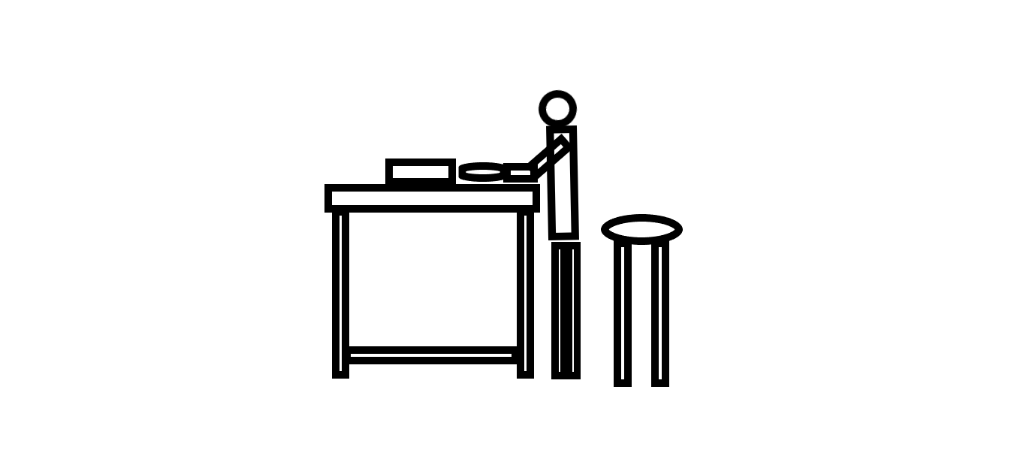

**Fig2.30 Conceptual art**

The evaluation of this conceptual artwork by RULA & REBA,

**Fig 2.31 RULA ASSESSMENT WORKSHEET**

**Fig 2.31 REBA ASSESSMENT WORKSHEET**

In this evaluation, RULA's risk score is 3 (Low), and REBA's risk score is 3. (Low). which indicates that when compared to the above 10 postures, this conceptual art helps to better posture and prevent back injuries.

**2.4 Standard operating procedure:**

**2.4.1 Applicable PPE:**



**Fig 2.32 Applicable PPE**

**2.4.2 Checklist:**

|  |  |  |  |  |  |
| --- | --- | --- | --- | --- | --- |
| **Date: Department:** | **EQUIPMENT INSPECTION CHECKLIST** | | | | **checklist no:** |
|
|
| **Project/Facility Name:** | | | | **Equipment No.** | |
| **Equipment Name:** | | | | | |
| **Company ☐** | **Contractor ☐** | **Sub-Contractor ☐** | | | **Others:** |
| **Note: Write Yes, No or N/A in the given box and if some comments, mention in the remark’s column.** | | | | | |
| **S. No** | **Description** | **Remarks** | | | **Remarks** |
| **Yes** | **No** | **N/A** |
| 1. | The grinding machine should be in good and working conditions. | ☐ | ☐ | ☐ |  |
| 2. | The power cable should be free from damages and connection have taken through Industrial plug. | ☐ | ☐ | ☐ |  |
| 3. | A flexible cord should be provided to keep the cable free from damage. | ☐ | ☐ | ☐ |  |
| 4. | Motor capacity should be marked in RPM. | ☐ | ☐ | ☐ |  |
| 5. | Deadman switch should be in working condition. | ☐ | ☐ | ☐ |  |
| 6. | The handle should be provided for better control. | ☐ | ☐ | ☐ |  |
| 7. | Wheel guard should be properly installed with the machine, so that gap between the guard and wheel should not be more than 3 mm. | ☐ | ☐ | ☐ |  |
| 8. | The grinding/cutting wheel should be free from defects and rotating capacity should be marked. | ☐ | ☐ | ☐ |  |
| 9. | The grinding machine should be double insulated otherwise grounded. | ☐ | ☐ | ☐ |  |
| 10. | Always use the designated key for removing and changing the wheel | ☐ | ☐ | ☐ |  |
| 11. | The machine is operated by a competent person. | ☐ | ☐ | ☐ |  |
| 12. | The RPM of the wheel should be more than the RPM of the motor. | ☐ | ☐ | ☐ |  |
|  | | | | | |
| **FIT ☐** | **Partially Fit ☐** | **Unfit ☐** | | | |
| **Inspected by, Name:** | | | | | |
|
| **Department:** | | | | | |
| **Signature:** | | | | | |

**2.4.3 Do & Don’t:**

|  |  |
| --- | --- |
| |  | | --- | | **HAND GRINDING** | | |
|
|
| **Do’s** |
| * DO CHECK all wheels for CRACKS or DAMAGE before mounting. |
| *  DO make sure the OPERATING SPEED of the Machine does not exceed the RATED WHEEL SPEED. |
| * DO always HANDLE and STORE wheels in a careful manner. |
| * DO be sure wheel hole FITS MACHINE ARBOR PROPERLY and the flanges are clean, flat, and the proper type and size for the wheel you are mounting. |
| * DO always RUN WHEEL in a PROTECTED AREA at least one minute before grinding. |
| * DO USE WHEEL GUARD furnished with machine. |
| * DO always WEAR PROTECTIVE SAFETY GLASSES or proper face shield. |
| * DO use COMMON SENSE SAFETY PRACTICES and adhere to all local laws and regulations. |
| **Don’ts** |
| ꭓ       DON'T use wheels which have been DROPPED or otherwise DAMAGED. |
| ꭓ       DON'T use EXCESSIVE PRESSURE WHEN MOUNTING wheel between flanges. Tighten nut only enough to hold wheel firmly. |
| ꭓ       DON'T use a grinding wheel that has a RATED SPEED LESS than the speed of the grinder. |
| ꭓ       DON'T HANDLE MACHINE CARELESSLY. Racks or hooks should be used to support machine when not in use. |
| ꭓ       DON'T use HEAVY SIDE GRINDING PRESSURE on any Type 1 (flat sided) wheel. |
| ꭓ       DON'T MOUNT MORE THAN ONE WHEEL on a single arbor. |
| ꭓ       DON'T use a machine for an INAPPROPRIATE APPLICATION. |
| ꭓ       DON'T use a machine WITHOUT PROPER SAFETY GUARD mounted securely in place. |

**3. Conclusion:**

To avoid avoidable accidents brought on by poor working postures, ergonomic research and its designs are very helpful. Through this project, the worker has had the chance to comprehend the fundamental issue that he encounters in the course of his regular workday activities and to develop the required suggestions, engineering controls, and design recommendations for the Grinding activities. Incorporating ergonomics training into participatory activities like design reviews, risk analyses, focus groups, and quality circles is another option in addition to official ergonomics training. It can also be picked up on the job by using checklists and tools designed to find risks and address issues.

* To keep their knowledge current or to acquire new skills, all employees need frequent training.
* For various jobs and employees, as well as for the skills and knowledge that must be acquired, different training methodologies are used.
* Worker participation and training are essential for the application of ergonomics so that employees can comprehend why changes are required and how to use them most effectively.

An increase in overall productivity and a decrease in employee absenteeism can be observed through the use of ergonomic studies of the workplace, both of which lead to cheaper insurance and workers compensation costs.

**References:**

[1] A. T. Siswantoro, I. N. Adiputra, I. D. P. Sutjana, and Adiatmika, “ERGONOMIC BASED MODIFICATION OF HAND GRINDER TO IMPROVE PHYSIOLOGICAL RESPONSES, AND TO INCREASE PRODUCTIVITY AND USER SATISFACTION.”

[2] C. R. Reid, P. McCauley Bush, W. Karwowski, and S. K. Durrani, “Occupational postural activity and lower extremity discomfort: A review,” *Int J Ind Ergon*, vol. 40, no. 3, pp. 247–256, May 2010, doi: 10.1016/j.ergon.2010.01.003.

[3] G. Piligian, R. Herbert, M. Hearns, J. Dropkin, P. Landsbergis, and M. Cherniack, “Evaluation and Management of Chronic Work-Related Musculoskeletal Disorders of the Distal Upper Extremity,” 2000.

[4] M. Hagberg, “Clinical assessment of musculoskeletal disorders in workers exposed to hand-arm vibration,” in *International Archives of Occupational and Environmental Health*, 2002, vol. 75, no. 1–2, pp. 97–105. doi: 10.1007/s004200100283.

[5] F. Caputo, A. Greco, M. Fera, and R. Macchiaroli, “Workplace design ergonomic validation based on multiple human factors assessment methods and simulation,” *Prod Manuf Res*, vol. 7, no. 1, pp. 195–222, Jan. 2019, doi: 10.1080/21693277.2019.1616631.

[6] Qutubuddin S M, S. S. Hebbal, and A. C. S. Kumar, “An ergonomic study of work related musculoskeletal disorder risks in Indian Saw Mills.” [Online]. Available: www.iosrjournals.org

[7] D. Kee, “Comparison of OWAS, RULA and REBA for assessing potential work-related musculoskeletal disorders,” *Int J Ind Ergon*, vol. 83, May 2021, doi: 10.1016/j.ergon.2021.103140.

[8] M. A. Zaini and F. N. Jannah, “POSTURE ANALYSIS WITH REBA AND RULA METHODS AT PT. PAGILARAN BATANG CENTRAL JAVA,” *International Journal of Innovation Scientific Research and Review*, vol. 03, pp. 1721–1725, 2021, [Online]. Available: http://www.journalijisr.com

[9] S. R. Stock, “Workplace Ergonomic Factors and the Development of Musculoskeletal Disorders of the Neck and Upper Limbs: A Meta-Analysis,” 1991.

[10] M. ève Chiasson, D. Imbeau, K. Aubry, and A. Delisle, “Comparing the results of eight methods used to evaluate risk factors associated with musculoskeletal disorders,” *Int J Ind Ergon*, vol. 42, no. 5, pp. 478–488, Sep. 2012, doi: 10.1016/j.ergon.2012.07.003.

[11] Y. K. Kong, S. yong Lee, K. S. Lee, and D. M. Kim, “Comparisons of ergonomic evaluation tools (ALLA, RULA, REBA and OWAS) for farm work,” *International Journal of Occupational Safety and Ergonomics*, vol. 24, no. 2, pp. 218–223, Apr. 2018, doi: 10.1080/10803548.2017.1306960.

[12] K. S. Tee *et al.*, “A study on the ergonomic assessment in the workplace,” in *AIP Conference Proceedings*, Sep. 2017, vol. 1883. doi: 10.1063/1.5002052.

[13] G. C. David, “Ergonomic methods for assessing exposure to risk factors for work-related musculoskeletal disorders,” *Occupational Medicine*, vol. 55, no. 3. pp. 190–199, May 2005. doi: 10.1093/occmed/kqi082.

[14] M. M. Cremasco, A. Giustetto, F. Caffaro, A. Colantoni, E. Cavallo, and S. Grigolato, “Risk assessment for musculoskeletal disorders in forestry: A comparison between RULA and REBA in the manual feeding of a wood-chipper,” *Int J Environ Res Public Health*, vol. 16, no. 5, Mar. 2019, doi: 10.3390/ijerph16050793.